*Task ON S3,R53,CDN*

*Configure VPC peering in cross regions.*

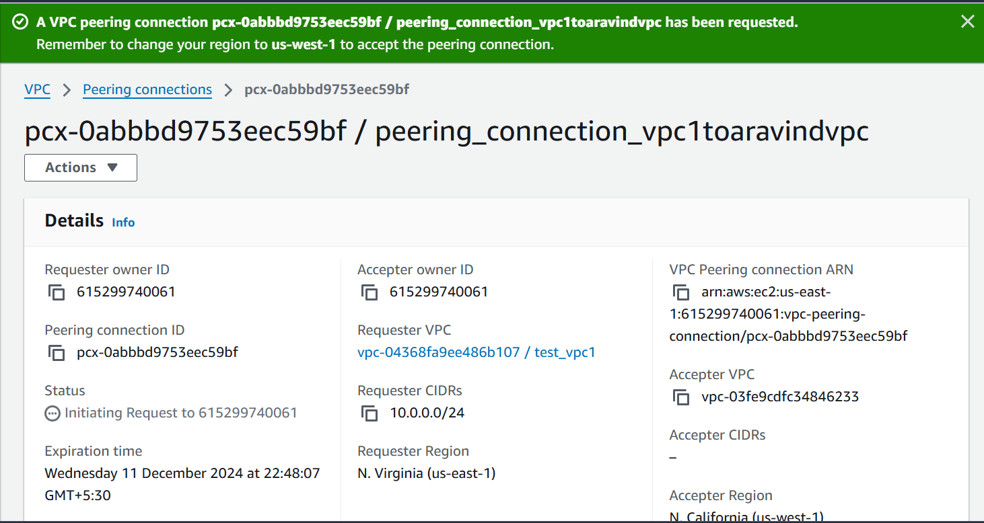

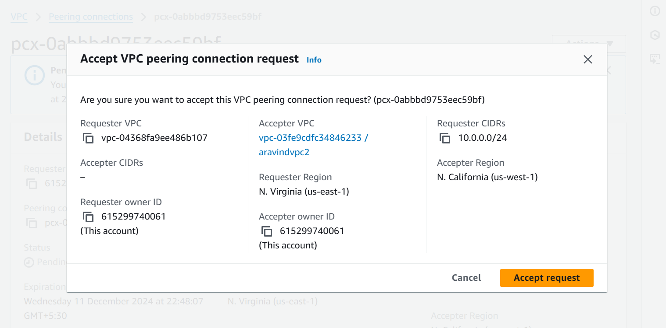

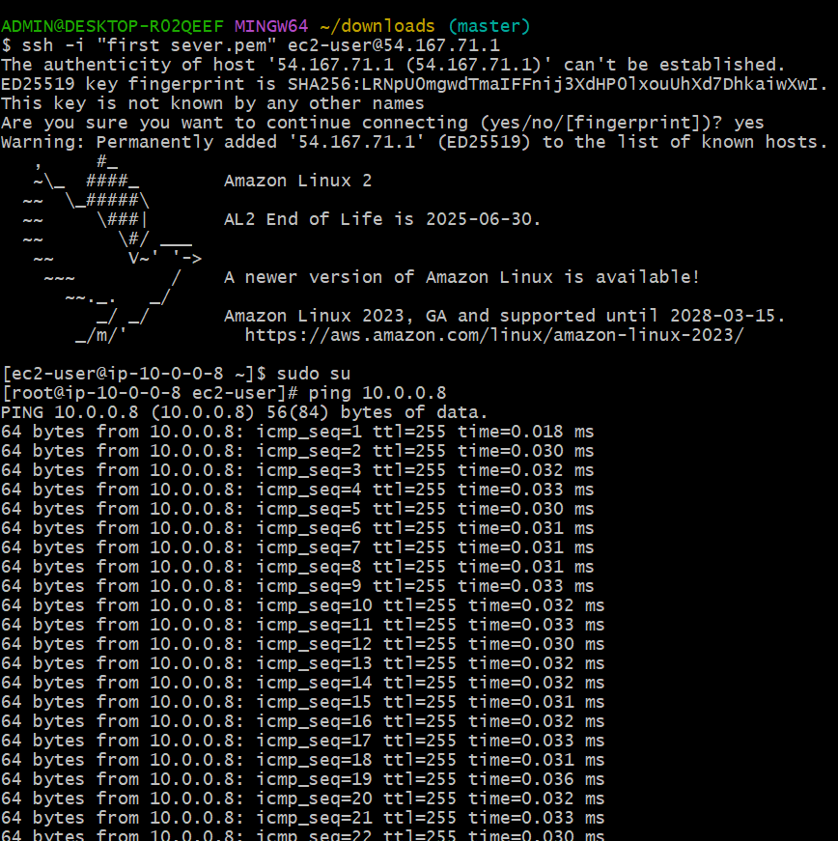

*Purchase one domain from GoDaddy.*

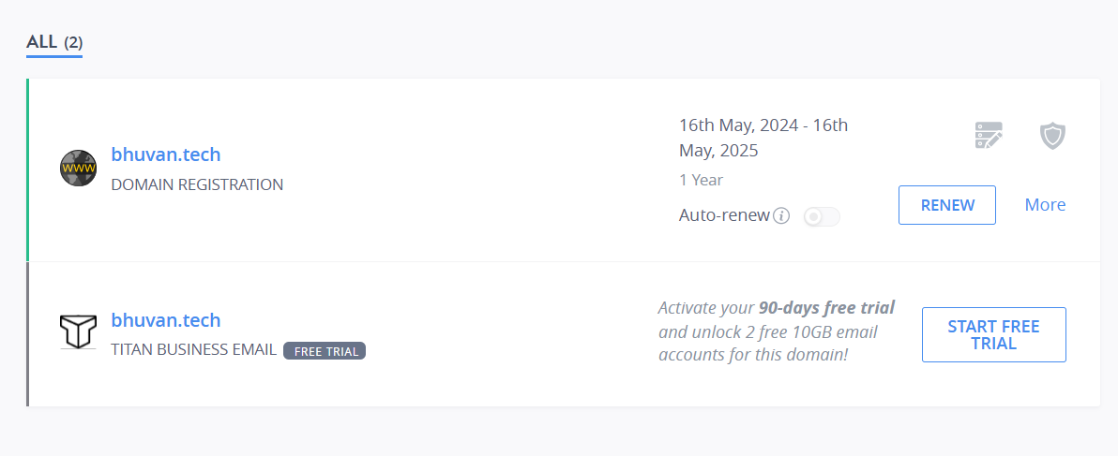

*Deploy static website in s3.*

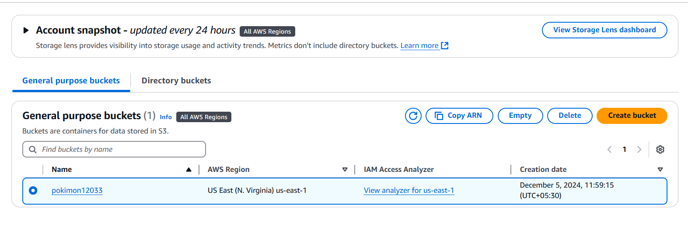

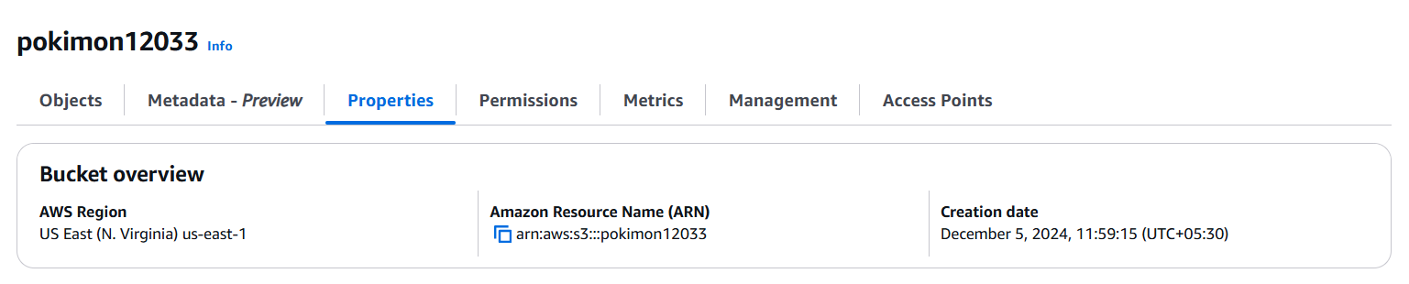

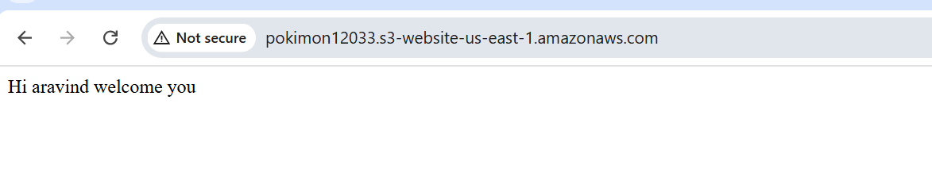

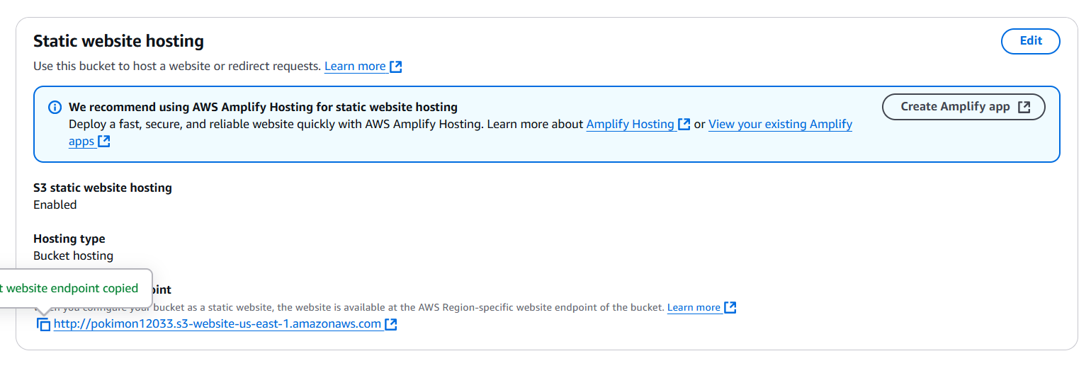

*Create CDN and attach one SSL certificate.*

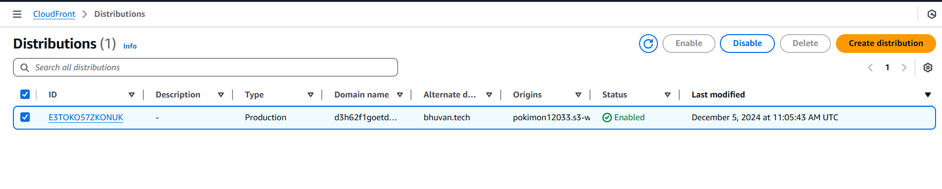

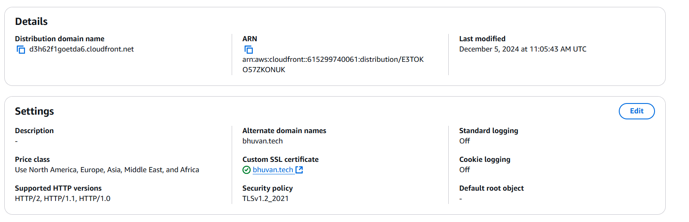

*Create Route53 hosted zone and MAP the domain with CDN.*

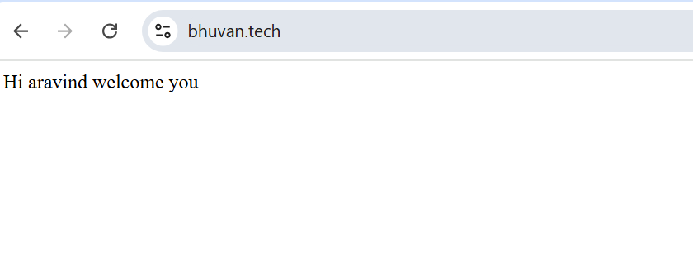

*Share the Domain name in slack to test the connectivity.*

***bhuvan.tech***